**Creating Microservices for Account and loan**

**AccountApplication.java**

package com.cognizant.account;

import org.springframework.boot.SpringApplication;

import org.springframework.boot.autoconfigure.SpringBootApplication;

@SpringBootApplication

public class AccountApplication {

public static void main(String[] args) {

SpringApplication.run(AccountApplication.class, args);

}

}

**AccountController.java**

package com.cognizant.account;

import org.springframework.web.bind.annotation.GetMapping;

import org.springframework.web.bind.annotation.PathVariable;

import org.springframework.web.bind.annotation.RestController;

@RestController

public class AccountController {

@GetMapping("/accounts/{number}")

public Account getAccount(@PathVariable String number) {

return new Account(number, "savings", 234343);

}

public static class Account {

private String number;

private String type;

private double balance;

public Account(String number, String type, double balance) {

this.number = number;

this.type = type;

this.balance = balance;

}

public String getNumber() {

return number;

}

public String getType() {

return type;

}

public double getBalance() {

return balance;

}

}

}

**LoanApplication.java**

package com.cognizant.loan;

import org.springframework.boot.SpringApplication;

import org.springframework.boot.autoconfigure.SpringBootApplication;

@SpringBootApplication

public class LoanApplication {

public static void main(String[] args) {

SpringApplication.run(LoanApplication.class, args);

}

}

**LoanController.java**

package com.cognizant.loan;

import org.springframework.web.bind.annotation.GetMapping;

import org.springframework.web.bind.annotation.PathVariable;

import org.springframework.web.bind.annotation.RestController;

@RestController

public class LoanController {

@GetMapping("/loans/{number}")

public Loan getLoan(@PathVariable String number) {

return new Loan(number, "car", 400000, 3258, 18);

}

public static class Loan {

private String number;

private String type;

private double loan;

private double emi;

private int tenure;

public Loan(String number, String type, double loan, double emi, int tenure) {

this.number = number;

this.type = type;

this.loan = loan;

this.emi = emi;

this.tenure = tenure;

}

public String getNumber() {

return number;

}

public String getType() {

return type;

}

public double getLoan() {

return loan;

}

public double getEmi() {

return emi;

}

public int getTenure() {

return tenure;

}

}

}

Account Output:-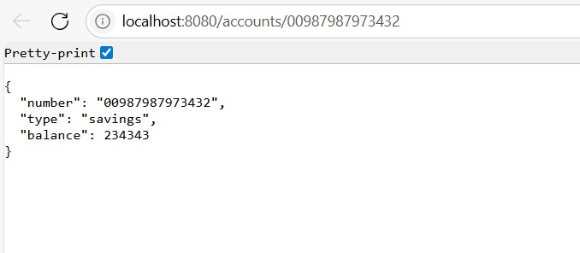

Loan Output:-

